# 

# An incubated co-working space for technology innovation

## Internal Document Template

**Application Proposal Document Template**

**Table of Contents**

1 Document Overview 1

1.1 Introduction and Purpose of this Document 1

1.2 Scope 1

2 Description of Application 2

2.1 Application Overview 2

2.2 Application Goals 2

2.3 Application Benefits 2

2.4 Application Completion Timeline 2

2.5 Application Languages Used 2

3 Application Approval 3

# Document Change Log

This is a working document, which will be maintained with time. Team members, please ensure that any changes are recorded in the change log below – this is to ensure that each team member is always clear about which changes have been made and when.

|  |  |  |  |
| --- | --- | --- | --- |
| **Version** | **Date** | **Author** | **Description** |
| 0.01 | 21 March 2015 | Malusi Gcakasi | Created initial template document. |
|  |  |  |  |

# Definition of Terms

|  |  |
| --- | --- |
| **Term** | **Definition** |
| Central Team | Team physically located at The Cortex Hub, East London |
| Remote Team | Team physically located outside of The Cortex Hub, East London |

# Description of Acronyms

|  |  |
| --- | --- |
| **Acronym** | **Description** |
| CH | The Cortex Hub |
| CT | Central Team |
| RT | Remote Team |
|  |  |
|  |  |
|  |  |
|  |  |

# Document Overview

## Introduction and Purpose of this Document

Since its inception at the beginning of January 2015, the goal of the Cortex Hub (CH) has been to create an innovative society that is able to sustainably leverage current technologies towards solving societal problems. The vehicle for achieving this goal has always been strong partnerships with universities, ICT providers, entrepreneurs and other business incubators to create a robust entrepreneurship ecosystem within the Eastern Cape (EC) region. Though the task is itself quite large, we believe that the right mix of committed people, enthusiasm and hard work will help in building the bridge between the dream we have proposed, and the gains of making it a reality.

Achieving this high goal will require the CH to “do great things in not quite enough time” In order to facilitate this, The CH must facilitate a culture of clarity, purpose and achievement; both in the programmes that it delivers to entrepreneurs and in the projects that it undertakes for their benefit. This document exists to sharpen our habits in this regard by providing a structured framework in which we will undertake our projects.

Before a project is undertaken for any purpose, this document must be completed in order to fully document the goal of the project, its proposed benefits, its projected timeline, the resources require and the RACI matrix that will define who is responsible for its completion. The document will aim to describe all of these in fine detail in order to facilitate smoother change processes in the project or fluctuations in scope or timeline.

## Scope

This document aims to record the actions undertaken in a project and the artefacts produced. It is does not aim to be a project report, however. This document aims only to be an initial overview description of the project when undertaken – a weekly report must still be completed in order to give an idea of fluctuations in timeline and workloads.

# Description of Application

Cortex Hub Intranet Website

## Application Overview

Sub section 1 – Overview of what the application is going to do and achieve.

An intranet is an information system with the same flexibility and power as the internet – but dedicated to internal users. It lets users communicate with each other, share information and resources, and even share software programs. It has restricted users – the staff in the organisation.

The Cortex hub intranet site will record activities or tasks for each entrepreneur, the time spent and the bandwidth usage. The purpose of this app is to check how entrepreneurs use the intranet as the source of information.

## Application Goals

Subsection 2 – Succinct summary of the goals to be achieved through the application.

The intranet play a valuable role as a communication channel, one that reaches all staff. This is typified by the news section on the intranet home page, which is used to communicate key corporate news items and updates.

* Share company information and computing resources among employees
* It provide a single , coordinated communications channel to all staff
* Improve the consistency of operations across the organisation
* Support the creation of a single corporate culture
* Provide a platform for business tools and systems
* Deliver staff productivity benefits

## Information sharing

Entrepreneurs and the Executive team can use the intranet to share information with the Remote team, especially during changes. As part of project management the intranet can be used to make expectations tasks and expectations clear.

## Freedom of expression

Provide a safe platform, such as a blog of discussion forum, for everyone to express their feelings and opinions in a professional and respectful manner. Entrepreneur who voice dissenting opinions shouldn’t be chastised.

## One vision

Use the intranet to “market” company’s vision and values. Use a tagline or motto, images, even colours to serve as a constant reminder of what the organisation stands for

## Application Benefits

Sub section 3 – Benefits to be gained by doing this application.

The benefits of this app are as follows:

* It will reduce costs – there will be no printing and paper requirements.
* Collaboration – It helps staff work together
* Efficiency utilisation of staff time arising from quicker access to information
* Improves communication
* Supports organisational culture
* Deliver content

## Application Completion Timeline

Sub section 4 – Timeline projected for the application.

1 Month

## Application Languages Used

Sub section 5 – Languages used for the application.

HTML, CSS, Java and JavaScript

J

# Skeleton

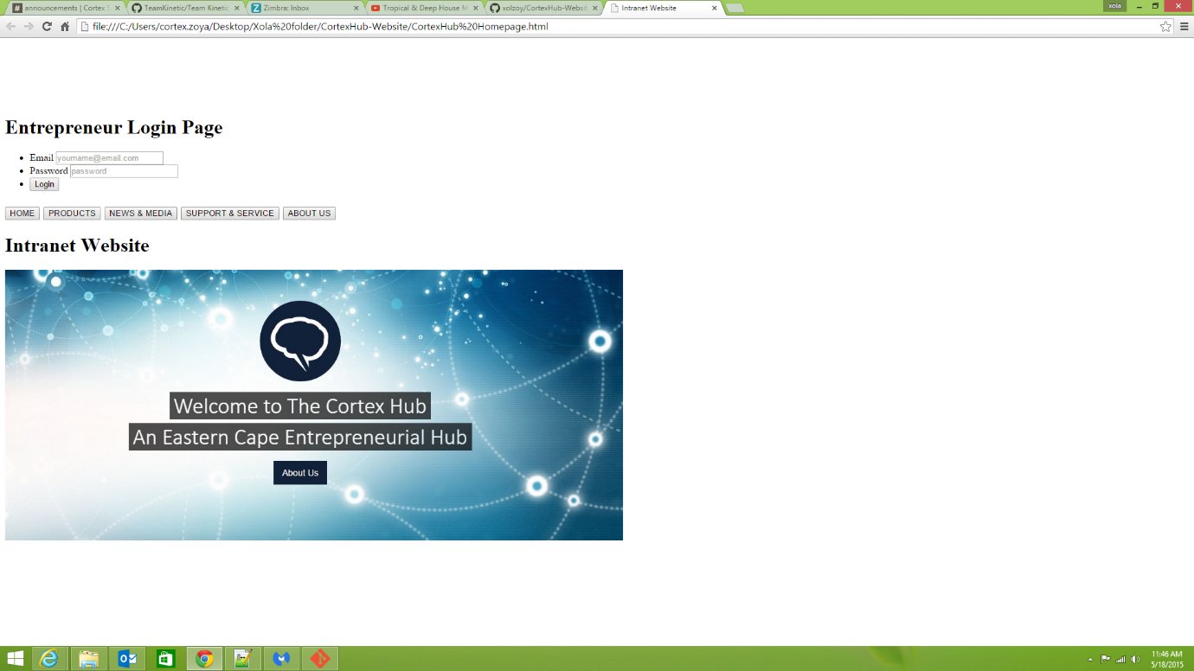But we still work on it

# Application Approval

This section formally approves that this document was completed, submitted, received and approved by the parties below

|  |  |  |
| --- | --- | --- |
| **Proposed By** | **Date Submitted** | **Signature** |
| Name of proposer  Xola Zoya  Nikiwe Nombi Gubeka  Bongiwe Ngqokoma | Date  17/05/2015 | X.Z.  N.N.G.  B.N.Record |
| **Approved By** | **Date Received** | **Signature** |
| Name of Project Approver | Date |  |
| **Consulted on this Application** | **Date Received** | **Signature** |
| Name of Consulted 1 | Date |  |
| Name of Consulted 2 | Date |  |
| Name of Informed | Date |  |